# **Name: Abdurrahman Qureshi**

# **Roll No: 242466**

Practical No: 6

1) Demonstrate Insertion and Deletion operation on Binary Search Tree

CODE

#include <stdio.h>

#include <stdlib.h>

#include <malloc.h>

*struct* node

{

*int* data;

*struct* node *left;

*struct* node *right;

};

*struct* node *tree;

*void* create_tree();

*int* insertElement();

*void* preorderTraversal();

*void* inorderTraversal();

*void* postorderTraversal();

*int* deleteElement();

*int* main()

{

*int* c, val;

*struct* node *ptr;

    create_tree(tree);

    do

    {

        printf("\n ******MAIN MENU******* \n");

        printf("\n 1. Insert Element");

        printf("\n 2. Preorder Traversal");

        printf("\n 3. Inorder Traversal");

        printf("\n 4. Postorder Traversal");

        printf("\n 5. Delete an element");

        printf("\n\n Enter your option : ");

        scanf("%d", &c);

        switch (c)

        {

        case 1:

            insertElement();

            break;

        case 2:

            preorderTraversal();

            break;

        case 3:

            inorderTraversal();

            break;

        case 4:

            postorderTraversal();

            break;

        case 5:

            deleteElement();

            break;

        }

    } while (c != 6);

    return 0;

}

*void* create_tree()

{

    tree = NULL;

}

*int* insertElement()

{

*struct* node *ptr, *nodeptr, *parentptr;

*int* val;

    ptr = (*struct* node *)malloc(sizeof(*struct* node));

    printf("\n Enter the value of the new node : ");

    scanf("%d", &val);

    ptr->data = val;

    ptr->left = NULL;

    ptr->right = NULL;

    if (tree == NULL)

    {

        tree = ptr;

        tree->left = NULL;

        tree->right = NULL;

    }

    else

    {

        parentptr = NULL;

        nodeptr = tree;

        while (nodeptr != NULL)

        {

            parentptr = nodeptr;

            if (val < nodeptr->data)

                nodeptr = nodeptr->left;

            else

                nodeptr = nodeptr->right;

        }

        if (val < parentptr->data)

            parentptr->left = ptr;

        else

            parentptr->right = ptr;

    }

    return tree;

}

*void* preorderTraversal()

{

    if (tree != NULL)

    {

        printf("%d\t", tree->data);

        preorderTraversal(tree->left);

        preorderTraversal(tree->right);

    }

}

*void* inorderTraversal()

{

    if (tree != NULL)

    {

        inorderTraversal(tree->left);

        printf("%d\t", tree->data);

        inorderTraversal(tree->right);

    }

}

*void* postorderTraversal()

{

    if (tree != NULL)

    {

        postorderTraversal(tree->left);

        postorderTraversal(tree->right);

        printf("%d\t", tree->data);

    }

}

*int* deleteElement()

{

*struct* node *cur, *parent, *suc, *psuc, *ptr;

*int* val;

    if (tree->left == NULL)

    {

        printf("\n The tree is empty ");

        return (tree);

    }

    printf("\n Enter the element to be deleted : ");

    scanf("%d", &val);

    parent = tree;

    cur = tree->left;

    while (cur != NULL && val != cur->data)

    {

        parent = cur;

        cur = (val < cur->data) ? cur->left : cur->right;

    }

    if (cur == NULL)

    {

        printf("\n The value to be deleted is not present in the tree");

        return (tree);

    }

    if (cur->left == NULL)

        ptr = cur->right;

    else if (cur->right == NULL)

        ptr = cur->left;

    else

    {

        psuc = cur;

        cur = cur->left;

        while (suc->left != NULL)

        {

            psuc = suc;

            suc = suc->left;

        }

        if (cur == psuc)

        {

            suc->left = cur->right;

        }

        else

        {

            suc->left = cur->left;

            psuc->left = suc->right;

            suc->right = cur->right;

        }

        ptr = suc;

    }

    if (parent->left == cur)

        parent->left = ptr;

    else

        parent->right = ptr;

    free(cur);

    return tree;

}

OUTPUT

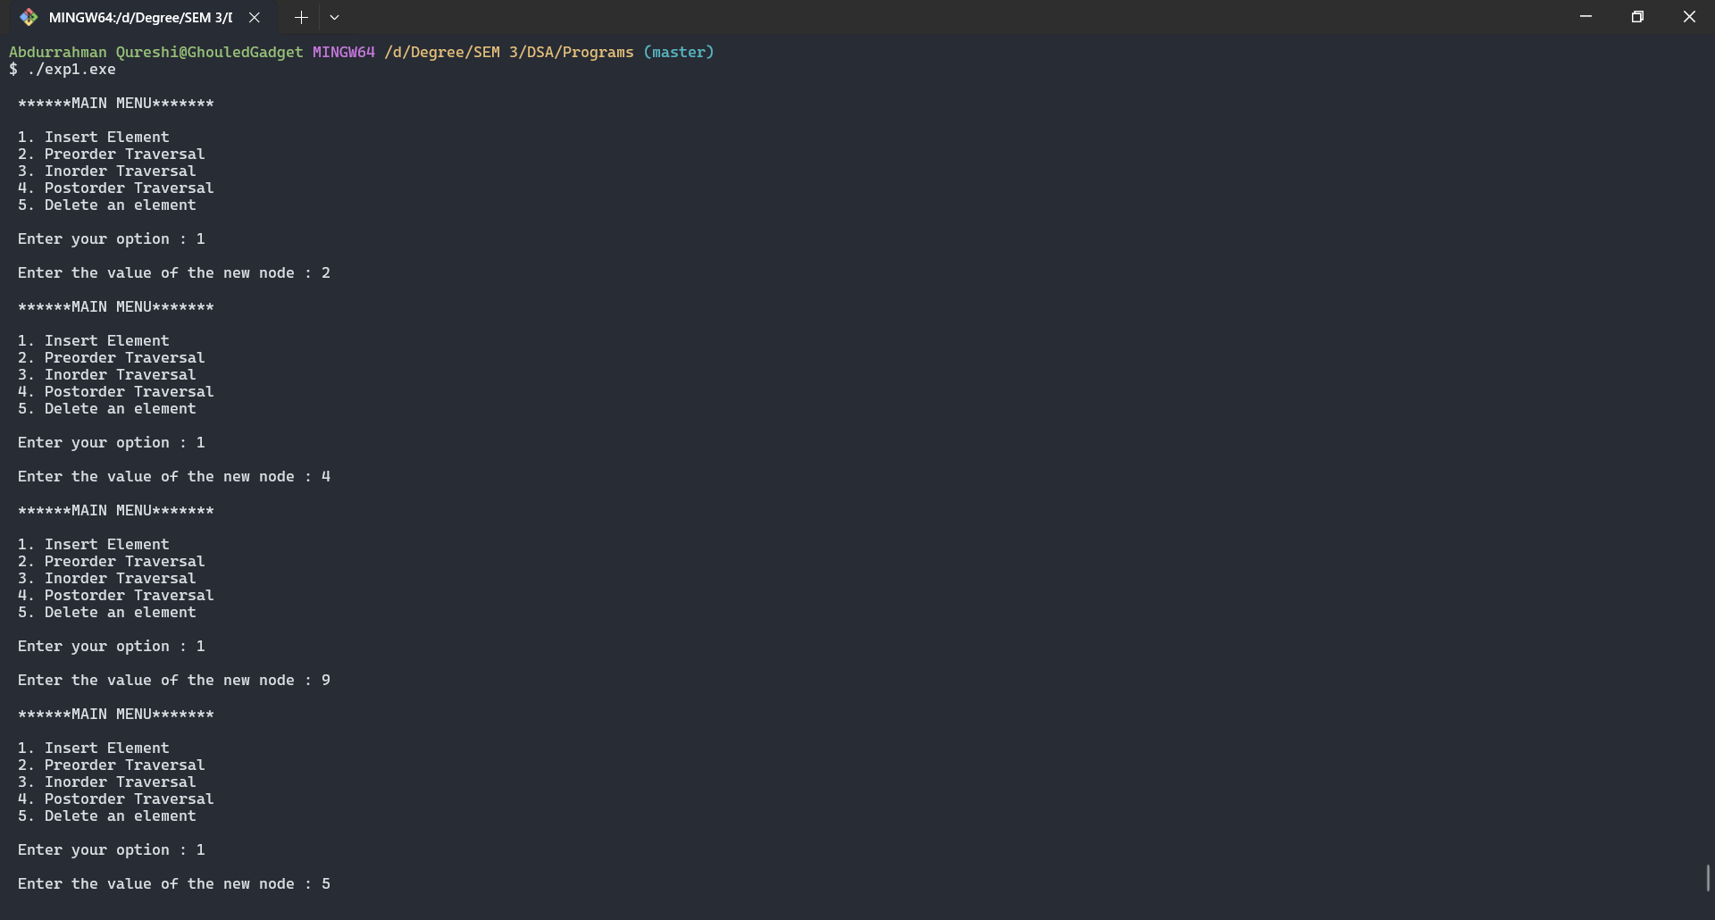

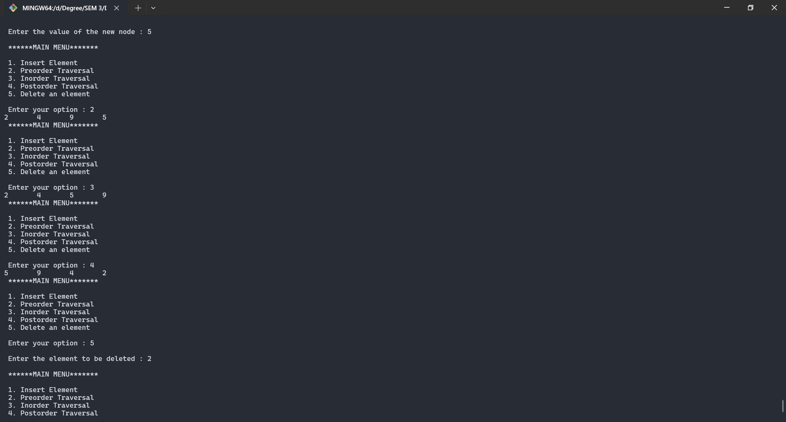

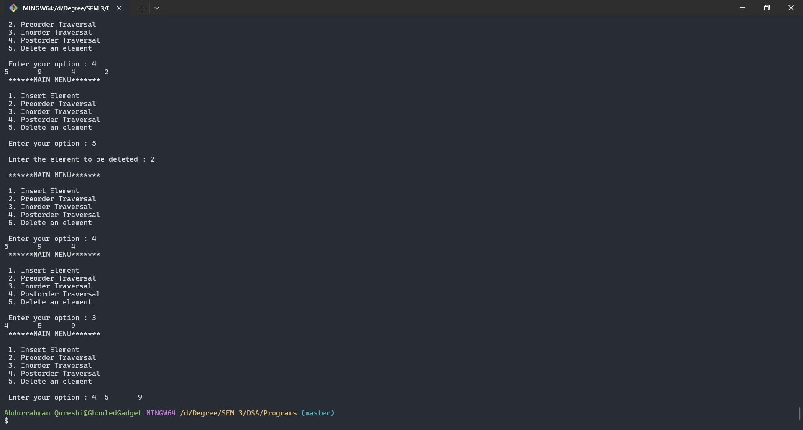

Tools used :

Software: Dev c++

Hardware: Lab Computers

References: Mam notes.

Conclusion

Binary Search Tree (or BST) is a special kind of binary tree in which the values of all the nodes of the left subtree of any node of the tree are smaller than the value of the node. Also, the values of all the nodes of the right subtree of any node are greater than the value of the node.